 Father and son

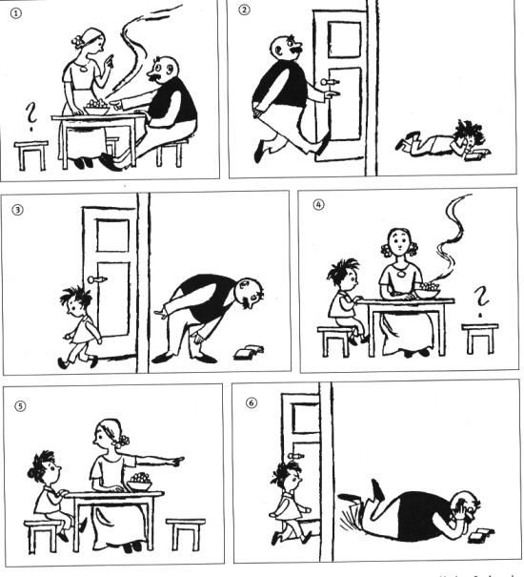

Use the following words to make a dialogue (you can use more words if you want) : Ready, supper, book, interesting, son, father, where, go, get, come, it is time for.

Do you have a funny story about your father or mother ?

